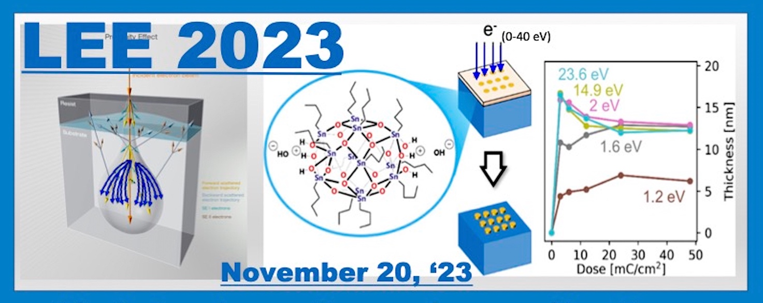
LEE 2023
Monday, November 20th, 2023
Università di Roma Tor Vergata,
Dipartimento di Ingegneria Elettronica- Aula Pitagora,
Via del Politecnico, 1 - 00133, Roma (Italia)

PARTICIPATION FORM

Please fill out this form and send by email to the following address:
stefano.iacobucci@ism.cnr.it
with object: LEE 2023 participation Name Surname.

Name_____________________________ Surname _____________________________________
Institution: _____________________________________________________________________
Work address:
Street ________________________________Town ___________________CAP _____________
email ________________________________
Telephone __________________________ Cellular___________________
􀀀 I plan to attend in person 􀀀 I plan to participate by TEAMS
􀀀 I consent to processing my personal data according to current legislation.

Date_______________________Signature_____________________________________________

